Mock Test!


Mock Test for BC: Final Stage – The Ultimate Challenge! 🎓✨

Congratulations on reaching the final stage of your training program! You've made it to the ultimate challenge: 2 rounds of Mock Tests—one for Retail and one for F&B.

Unlike the Full Pitching Assessment, this is a full-on mock test designed to simulate real training scenarios with a structured flow that you'll need to follow.

Your Tasks for the Mock Test:

- Apply Everything You’ve Learned: Use all the sales skills you’ve mastered over the past days.

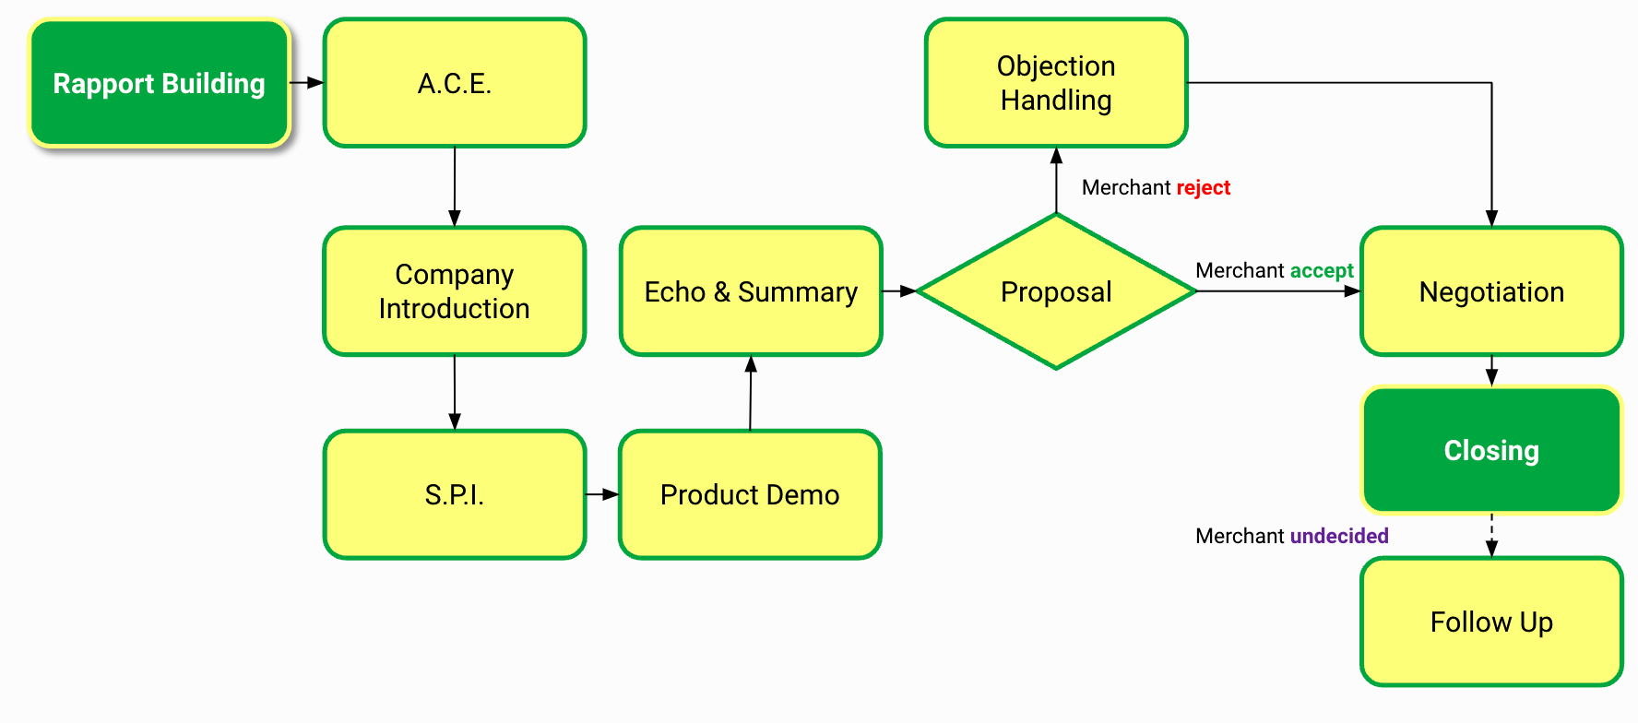
Mock Flow
- Set Up Your Backoffice: Follow the assigned scenario to set it up.
- Practice, Practice, Practice: The more you practice, the smoother your performance will be.

Your trainer will assign you specific scenarios for the Mock Test and inform you of the time slot. Invitations will be sent to both you and your coach.

During the Mock Test:

- Join the Google Meeting on Time – Be punctual; professionalism starts with being on time.
- Prepare Your iPad for the Demo – Ensure it's set up and ready for a smooth presentation.
- Have Your Calculator Ready – Present the BC Calculator during closing to clearly show the quoted amount to the merchant.

Pro Tip: Treat your coach like a real merchant and stick to the Mock Test flow during your pitching. The more realistic your approach, the better!

Good luck- you’ve got this! 🌟

